SET 5: WEBSITE ANALYTICS
Ayesha Siddiqa S
192324305
1. Line Chart – Daily Page Views
Aim
To create a line chart to visualize the trend in daily page views over time.
Algorithm
1. Create date and page-view vectors.
2. Convert dates to Date format.
3. Use plot() with type = 'o'.
4. Add axis labels and a title.
Code
date <- as.Date(c("2023-01-01", "2023-01-02", "2023-01-03",
"2023-01-04", "2023-01-05"))
page_views <- c(1500, 1600, 1400, 1650, 1800)
plot(date, page_views,
type = "o",
pch = 19,
xlab = "Date",
ylab = "Page Views",
main = "Daily Website Page Views")
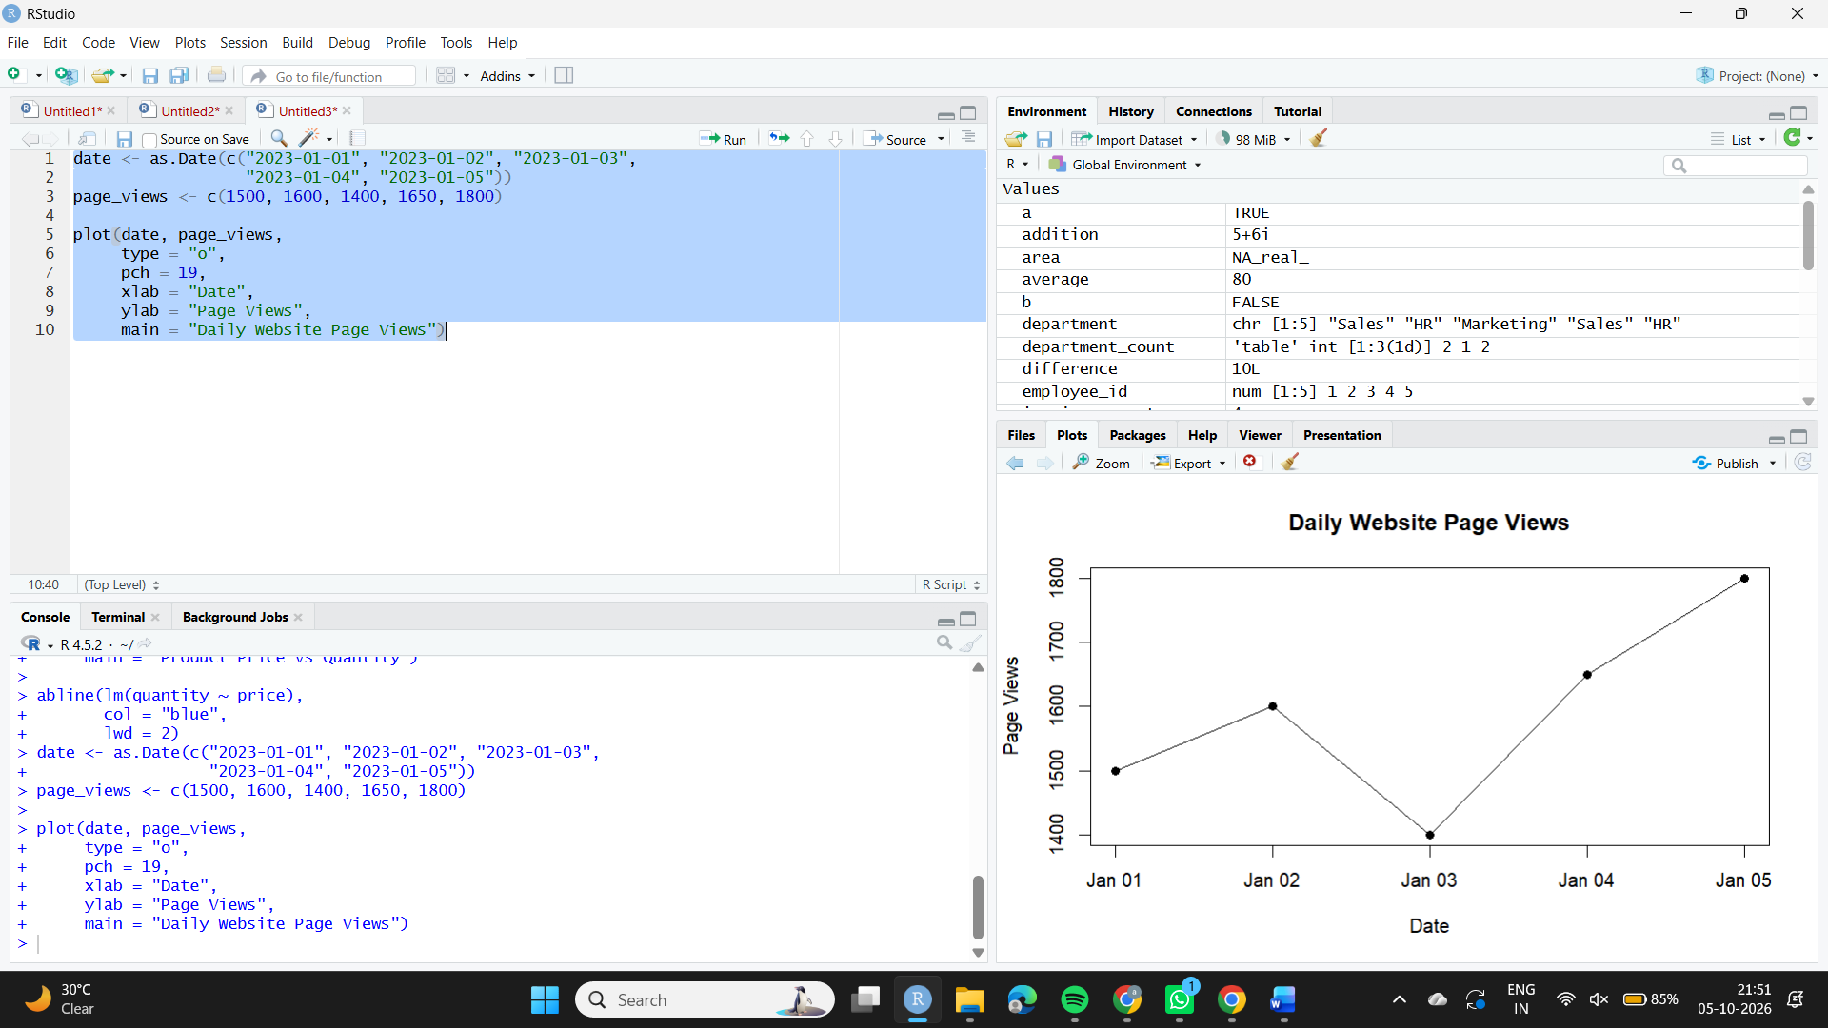
Observation
Page views reach the highest value of 1800 on January 5, while January 3 has the lowest value of 1400.

2. Bar Chart – Top N Days by Click-through Rate
Aim
To create a bar chart showing the days with the highest click-through rates.
Algorithm
1. Create date and CTR vectors.
2. Sort the data in descending order of CTR.
3. Select the top 3 days.
4. Use barplot() and add labels.
Code
date <- c("2023-01-01", "2023-01-02", "2023-01-03",
"2023-01-04", "2023-01-05")
ctr <- c(2.3, 2.7, 2.0, 2.4, 2.6)
data <- data.frame(Date = date, CTR = ctr)
data <- data[order(-data$CTR), ]
top_n <- head(data, 3)
barplot(top_n$CTR,
names.arg = top_n$Date,
col = "orange",
xlab = "Date",
ylab = "Click-through Rate (%)",
main = "Top 3 Days by Click-through Rate")
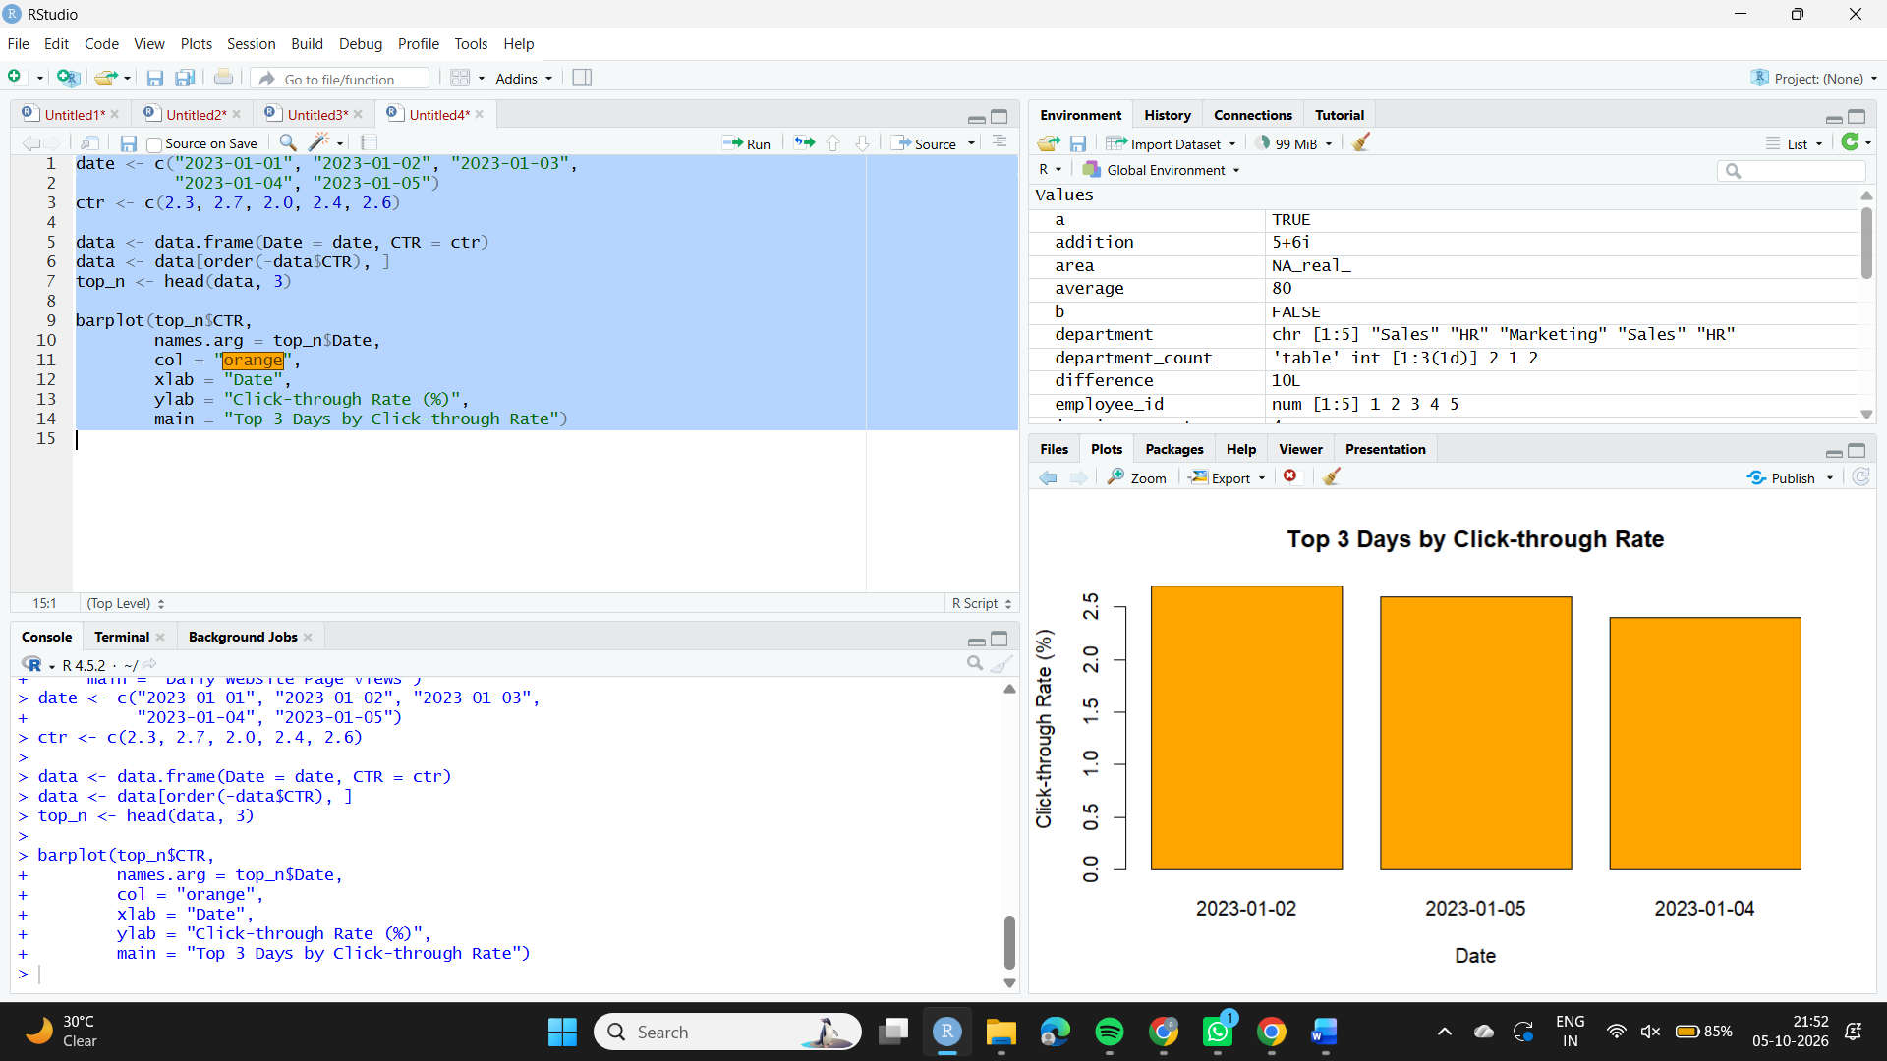
Observation
January 2 has the highest CTR (2.7%), followed by January 5 (2.6%) and January 4 (2.4%).

3. Stacked Area Chart – User Interactions
Aim
To create a stacked area chart showing likes, shares, and comments over time.
Algorithm
1. Create date and interaction vectors.
2. Calculate cumulative values for stacking.
3. Use polygon() to draw the stacked areas.
4. Add labels and a legend.
Code
date <- as.Date(c("2023-01-01", "2023-01-02", "2023-01-03",
"2023-01-04", "2023-01-05"))
likes <- c(120, 140, 110, 150, 170)
shares <- c(40, 50, 35, 55, 60)
comments <- c(20, 25, 18, 30, 35)
total2 <- likes + shares
total3 <- likes + shares + comments
x <- 1:5
plot(x, total3,
type = "n",
xaxt = "n",
xlab = "Date",
ylab = "Number of Interactions",
main = "Website User Interactions")
axis(1, at = x, labels = date)
polygon(c(x, rev(x)),
c(rep(0, 5), rev(likes)),
col = "lightblue", border = NA)
polygon(c(x, rev(x)),
c(likes, rev(total2)),
col = "lightgreen", border = NA)
polygon(c(x, rev(x)),
c(total2, rev(total3)),
col = "pink", border = NA)
legend("topleft",
legend = c("Likes", "Shares", "Comments"),
fill = c("lightblue", "lightgreen", "pink"))
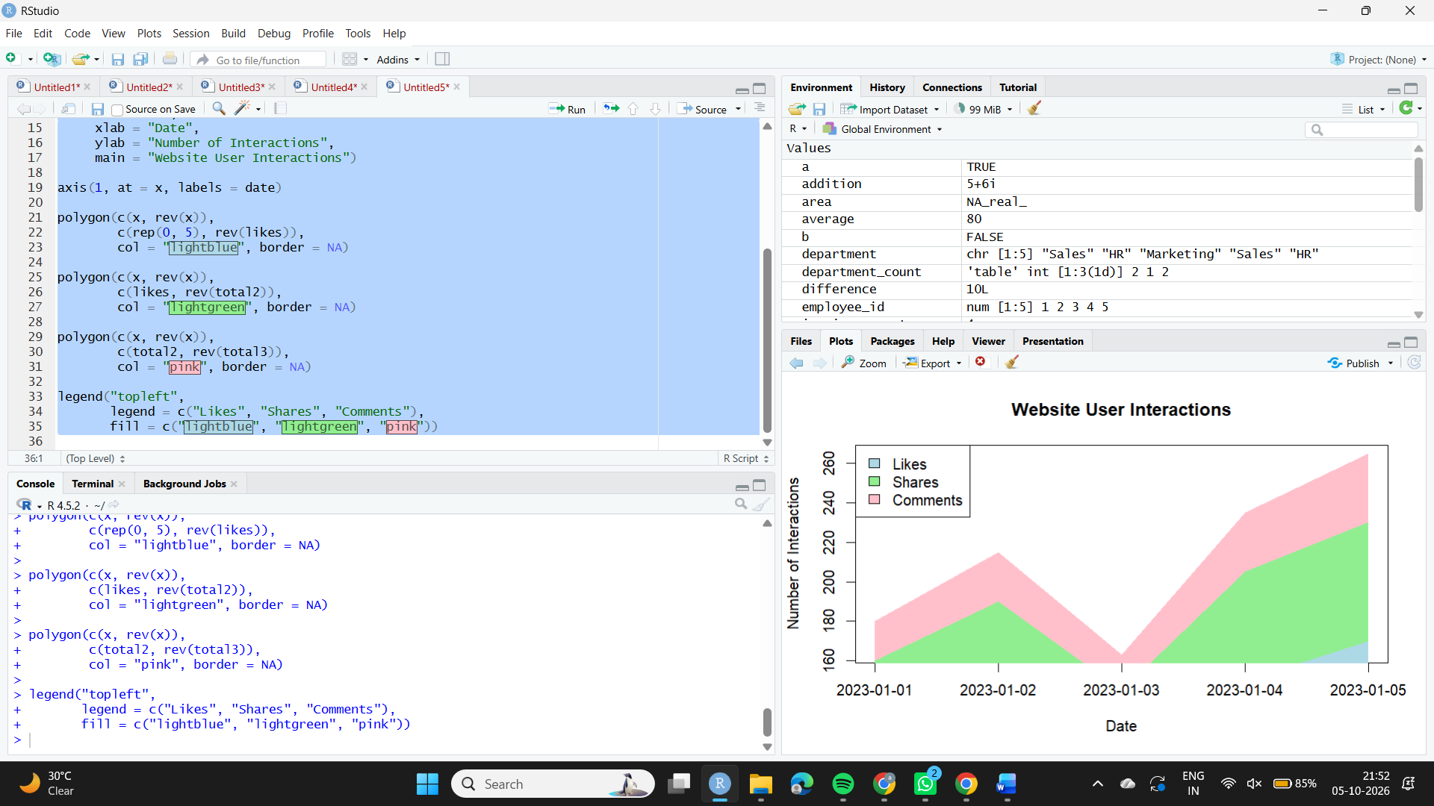

Observation
The stacked area chart shows the contribution of likes, shares, and comments over the five days. These interaction values are sample values because they were not included in the given dataset.

4. Tableau Dashboard
Aim
To develop an interactive Tableau dashboard combining the line chart and bar chart.
Algorithm
1. Create an Excel or CSV file with Date, Page Views, and CTR.
2. Connect the data to Tableau.
3. Create the page-view line chart.
4. Create the CTR bar chart.
5. Create a dashboard and add both sheets.
6. Add filters for interactive exploration.
Code
Create the two sheets in Tableau and drag them onto a new Dashboard. Add Date as a filter.
Observation
The dashboard allows users to interactively explore daily page views and click-through rates.

